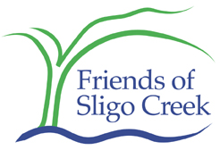

September 26, 2005

I am Ann Hoffnar, co-president of Friends of Sligo Creek.

We Friends of Sligo are pleased that we could take part in what we feel is a major success for the watershed. This settlement agreement is an important win for all of us, the parties to the suit and, even more important, the children and families who can enjoy a healthier environment.

Sligo Creek is a tributary stream. One of many in the large area WSSC serves. Our little creek begins in Montgomery County and flows into Prince Georges County. There it connects with the Northwest Branch and from there it flows to the Anacostia River.

Sligo Creek is only about 8 miles long, but it provides a wonderful refuge for wildlife and a welcome respite for people. Any weekend day you can come see how many people are playing in the park: walkers, bikers, kids playing in the stream.

Our organization is working to protect and restore the park. We ask people to come help clean up trash and cut invasive vines. And we have been concerned about their health. We know the water is not always safe for wading.

Now, thanks to this settlement agreement and the work that will be done under it, in a few years we will have a creek free from damaging sewage leaks and spills. We look forward to working with WSSC as this agreement is put into place.

